**Week 4 In class Lab**

|  |  |
| --- | --- |
| **Student Name** | Mazaharuddin Mohammad |
| **Student Number** | N01464978 |
| **Subject Name** | [Big](https://learn.humber.ca/webapps/blackboard/execute/courseMain?course_id=_187043_1) data 2 |
| **Professor Name** | Orren Johnson |

**Create a plot using mtcars**

First create a plot on mpg set the ylim to 50 and color is blue

Second add a line on cyl set the color to red with dashed line and square points

Make x axis the name of cars and the name should be vertical positioned

Add a title to the graph “Week 4 Lab 1 + your name

Create a legend for mpg and cyl respectively in the topleft corner that uses the same line colors and points

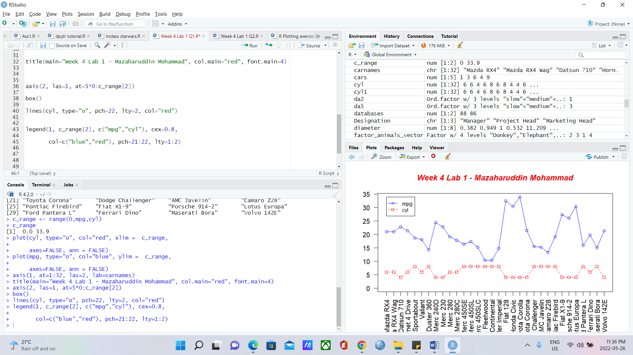

**Create a Pie chart using data USArrests**

Frist get the first 10 rows of USArrests and then set the rownames as labels

Use the rainbow for colors and murder as the variable

Add a legend to the top left_filled with the same rainbow colors

Add a title to the graph “Week 4 Lab 1 + your name

